RESTAURANT ANALYSIS ASSIGNMENT - COMPLETE SOLUTION
OBJECTIVE QUESTIONS

1. What is the total no. of tables present in the data?
Ans: There are two tables present in the data.
- Raw Data Table
- Country Description Table

2. What is the total no. of attributes present in the data?
Ans: There are 22 attributes present in the data.
- 20 attributes in the Raw Data table
- 2 attributes in the Country Description table

3. How many categorical columns are there in the data? [Search about categorical and continuous data, and try to answer this question]
Ans: There are 11 Categorical columns in the data.
- RestaurantName
- City
- Address
- Locality
- LocalityVerbose
- Cuisines
- Currency
- Has_Table_booking
- Has_online_delievery
- Is_delivery_now
- Switch_to_order_menu

4. The data consists of some inconsistent and missing values so ensure that the data used for further analysis is cleaned.
Approach: This is a directive for Level 2 (Cleaning). My approach involves a systematic cleaning process. First, I'd use Filtering to identify blanks in critical columns like "Cuisines" or "Average Cost." For missing values, I might either delete the row (if critical data is missing) or fill using logic (e.g., fill missing country names based on country code). Second, I'd use Sorting to find duplicates in the Restaurant ID column and remove them. Third, I'd use Text to Columns to split combined data (e.g., if "Cuisines" are listed as "Italian, Pizza", I might split them for better analysis, though careful consideration is needed).
Insights: Cleaning reveals the true quality of the dataset. I might find that 5% of restaurants have missing cuisines or that there are duplicate entries for the same restaurant. Ignoring this would skew insights—for instance, counting the same restaurant twice in the "Top 10 Cuisines" chart would be inaccurate. Ensuring data consistency (e.g., standardizing "New Delhi" and "New Delhi " using TRIM) ensures that filters work correctly.
- ROUND(IF(S2=0,AVERAGEIF($D$2:$D$9552,D2,$S$2:$S$9552),S2),0). This formula replaced zero values with the average cost for the restaurants in the same country(Column D), ensuring more accurate and meaningful data.

- In the city column, many cities names were incorrectly entered. I reviewed the list and corrected all inaccurate names using the Find & Replace feature. The cities that required corrections were:

- Savannnah
- Sí£o Paulo
- Brasí_lia
- ÛÁstanbul
- Vizag
- Bhubaneshwar.

I updated these to their correct spellings as follows:
- Savannah – Savannah
- Sí£o Paulo - São Paulo
- Brasí_lia – Brasília
- ÛÁstanbul -Istanbul
- Vizag - Visakhapatnam
- Bhubaneshwar – Bhubaneswar

Recommendations: After cleaning, I strongly recommend creating a new "data Cleaned" sheet, leaving the original raw data untouched. This ensures traceability. I would also use Data Validation in key columns of any future input sheets to prevent bad data entry (e.g., restricting "Currency" to a dropdown list) as a long-term solution.

5. Using the VLookup functions, fill up the countries in the original data using the country code.
Approach: This is a Level 5 task. Assuming we have two tables: the main data table (with 'Country Code') and a lookup table (with 'Country Code' and 'Country Name'). I would use the XLOOKUP function (or VLOOKUP) in a new column in the main data. The formula would be: =VLOOKUP([@[Country Code]], LookupTable[Country Code], LookupTable[Country Name], "Not Found"). This searches for the code from the main data in the lookup table and returns the corresponding country name.
Insights: This process merges the datasets, transforming cryptic numerical codes into understandable labels. This is crucial because analyzing data by "Country Code 1" is meaningless to stakeholders, whereas analyzing by "India" or "USA" provides immediate geographic context. It also validates the lookup table; if a code returns "Not Found," it indicates a data integrity issue in the source.
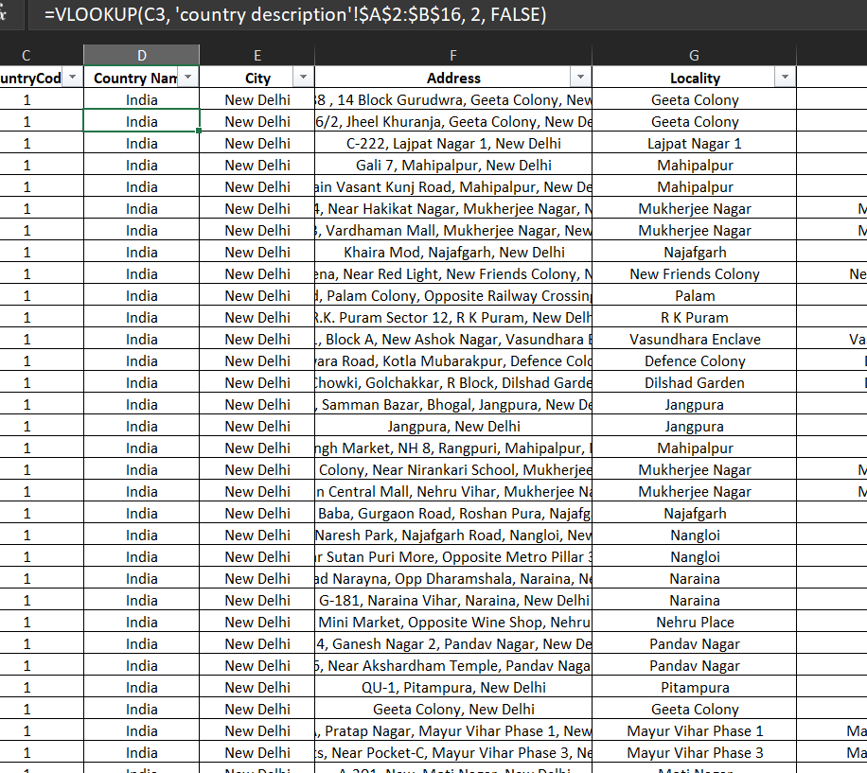

6. Create a table to represent the number of restaurants opened in each country.
Approach: With the 'Country' column now populated from the previous step, creating this table is straightforward. I would select the entire 'Country' column and insert a Pivot Table (Level 6 skill). In the Pivot Table fields, I would drag the 'Country' field into the 'Rows' area and another field like 'Restaurant ID' or 'Name' into the 'Values' area, ensuring the aggregation is set to 'COUNT'. This instantly generates a clean, sorted table showing the restaurant count per country.

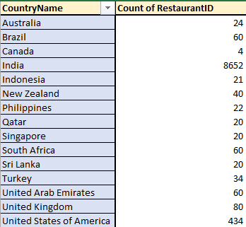
Insights: This table provides a clear hierarchy of markets. It will immediately show which countries have the highest restaurant density (market saturation) and which have the lowest. For example, if India has 8,000 restaurants and Indonesia has only 50, the table highlights India as a saturated, highly competitive market and Indonesia as a potential blue ocean.
Recommendations: This table should be a core component of the final dashboard. I would sort it in descending order to draw attention to the top markets. I would also suggest using this table in conjunction with other metrics (like average rating per country) to make informed decisions—a country with few restaurants but high average ratings might be a hidden gem.
Visualizations: While the prompt asks for a table, the best way to present this is a horizontal bar chart (as mentioned in the dashboard requirements). The table is the data source for the chart.

7. Also, the management wants to look at the number of restaurants opened each year, so provide them with something here.
Approach: To analyze openings per year, I need a valid 'Year' column. If the data has an 'Opening Date' column, I would extract the year using the YEAR() function (Level 4 skill) in a new column (e.g., =YEAR([@[Opening Date]])). Then, I would create another Pivot Table. I would drag the newly created 'Year' field into 'Rows' and 'Restaurant ID' into 'Values' (Count). This shows the trend of restaurant openings over time.
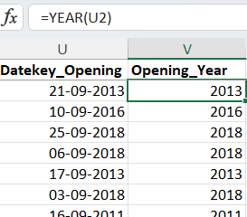
Insights: This analysis reveals growth trends. A line chart created from this Pivot Table might show a steady increase in openings year over year, indicating a booming food industry. A sudden dip might correspond to an economic event or a global pandemic. It helps management understand if the market is expanding or contracting.
Recommendations: For the dashboard, I would present this data as a Line Chart to effectively show the trend over time. I would also add a trendline to forecast future growth. This chart should be interactive with a year slicer, allowing management to select a specific year and see corresponding data in other charts (e.g., if they select 2020, the country-wise chart updates to show only restaurants opened in 2020).

Visualizations: A coloumn Chart titled "Restaurant Openings Trend (Yearly)" is the most effective visualization for this time-series data, clearly showing peaks, valleys, and overall growth trajectory.

8. What is the total number of restaurants in India in the price range of 4?
Approach: This is a conditional count requiring two criteria: Country = India and Price Range = 4. I can solve this using a Pivot Table (drag Country to Rows, Price Range to Columns, and Count of Restaurants to Values) and then read the intersecting value. Alternatively, I can use the COUNTIFS() function (Level 4) in Excel/Sheets: =COUNTIFS(Country_Column, "India", Price_Range_Column, 4). This function counts rows that meet both conditions simultaneously.

Insights: This number indicates the size of the premium/luxury dining segment (assuming Price Range 4 is the highest) in the Indian market. If this number is high, it suggests a mature market with strong demand for high-end dining. If it's low, it could mean the premium segment is niche and underdeveloped, presenting either a risk or an opportunity for a first-mover advantage.

9. What is the average number of voters for the restaurants in each country according to the data?
Approach: This requires a grouped average. The best tool is a Pivot Table. I would drag the 'Country' field into Rows and the 'Votes' field into Values. By default, it might show the 'Sum' of votes, so I would click on the value field settings and change the aggregation from 'SUM' to 'AVERAGE'. This will instantly calculate the mean number of voters for restaurants within each country.
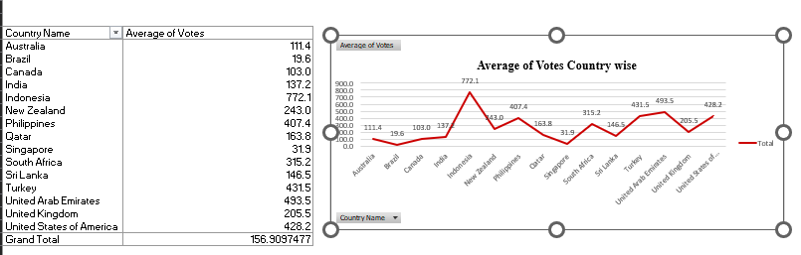

Insights: The 'Average Votes' serves as a strong proxy for customer engagement or restaurant popularity. A high average number of votes indicates that restaurants in that country generally receive a lot of customer feedback, implying a culture of online engagement. A low average might suggest that while restaurants exist, the customer base is not digitally active, or the review culture is nascent. Comparing this to average ratings can be insightful.
Recommendations: This metric should be visualized alongside other country data. I recommend creating a Combination Chart or a Scatter Plot with "Average Rating" on one axis and "Average Votes" on the other. This could reveal clusters: countries with high ratings but low votes (hidden gems) vs. high ratings and high votes (popular favorites).
Visualizations: A Line Chart showing "Average Votes by Country" is the primary visualization. Sorting this line chart can quickly reveal which markets have the most engaged customer bases.

10. Calculate the average rating for all the restaurants that have price_range < 4 and provide online delivery. Use only the “IF” function, Logical Operators, and Aggregation functions to solve this problem. [Note: Don't use Conditional aggregation in this question.]
Approach: This is a Level 3 logic challenge, as it prohibits using AVERAGEIFS. I need an array-like approach. I would create a new helper column. The formula would be: =IF(AND([@[Price Range]]<4, [@[Online Delivery]]="Yes"), [@Rating], ""). This uses the IF and AND logical operators. It checks both conditions; if true, it outputs the rating; if false, it outputs a blank. Finally, I would use =AVERAGE(helper_column) and =COUNT(helper_column) on a separate cell to calculate the average of the non-blank cells, which automatically excludes the falses.

Insights: This calculation isolates the performance of a specific segment: budget-friendly restaurants (Price Range 1-3) that offer convenience (online delivery). The resulting average rating tells us how this combination of affordability and service is perceived. A high average here would validate the strategy of focusing on delivery for mid-to-low-priced eateries.

11. Using Conditional formatting highlight the rows of restaurants that are located in the countries or cities that you've suggested to the management for opening new restaurants.
Approach: First, I need to finalize my list of suggested countries/cities from the subjective analysis. Let's assume I suggested "Austin, USA" and "Bangalore, India". I would select all the data rows (excluding header) and apply Conditional Formatting (Level 3) using a custom formula. The formula wouldbe: =OR(AND($C2="Srilanka",$D2="Colombo"),AND($C2="Newzealand", $D2="Jakarta")) (adjusting column letters for Country and City). This highlights the entire row if the conditions are met.
Insights: This visual highlighting immediately draws the eye to the specific restaurants of interest within the massive dataset. It turns a table of thousands of rows into a focused view, allowing the management to scan and see the characteristics of competitors in the target locations without filtering out the rest of the data. It provides context.
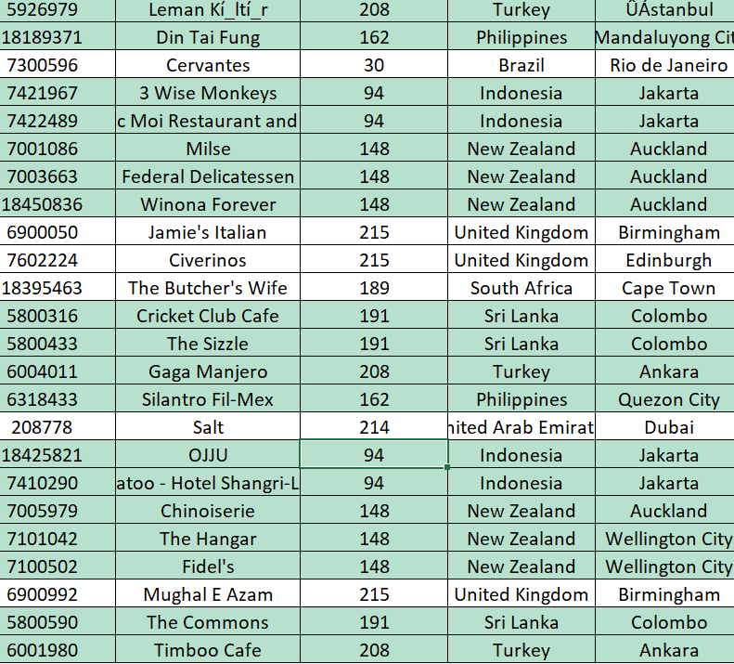
Recommendations: I would use a bright but professional fill color (like light green) for the highlighted rows. I would also add a note in the documentation explaining the rule (e.g., "Rows highlighted in green represent potential competitor restaurants in target cities"). This makes the spreadsheet interactive and self-explanatory for anyone reviewing it.
Visualizations: The data table itself becomes the visualization. The colored rows serve as a powerful visual cue, making the recommended locations stand out instantly against the unformatted rows.

12. Create a new customized price column that consists of the abbreviation/symbol of the currency along with the Average_cost_for_two_value. [Use string operations to do this task]
Approach: This is a Level 4 string operation task. Assuming I have a column for 'Currency' (e.g., USD, INR, GBP) and a column for 'Average Cost for Two'. I would create a new column and use the CONCATENATE function or the & operator. For example: =CONCATENATE([@Currency], " ", [@[Average Cost for Two]]) or =[@Currency]&" "&TEXT([@[Average Cost for Two]],"#,##0"). Using the TEXT function formats the number with commas for better readability (e.g., "INR 1,200").
Insights: This new column creates a human-readable, presentation-ready field. Raw data often stores cost as a number and currency separately. Combining them into one string makes tables and tooltips in charts much easier to understand at a glance. It eliminates the need for the viewer to mentally combine two columns.
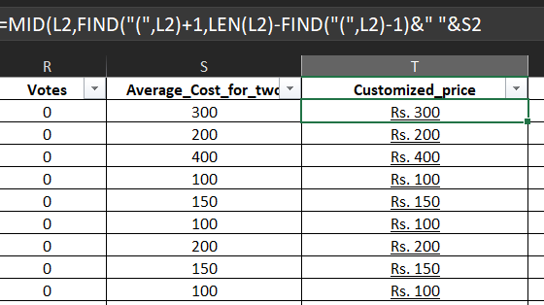
Recommendations: I recommend using this new column in any tables or tooltips within the dashboard. However, for calculations (like converting to INR), the original numerical cost column must still be used. This new column is purely for display. I would place it next to the original cost column for easy reference.

13. How can you create an array formula in Excel or Google Sheets to count the number of restaurants listed that do not offer online delivery, are in the lowest price range, and have an average cost for two people less than or equal to 250 Indian Rupees?
Approach: This Level 9 (Array Formulas) task requires a single formula to count rows meeting multiple conditions without helper columns. Assuming the data is filtered for India (or cost already in INR), in Google Sheets, I would use: =COUNTIFS(Online_Delivery_Column, "No", Price_Range_Column, 1, Cost_Column, "<="&250). In Excel, COUNTIFS is a standard function. If the cost is in various currencies, I would first need to convert them all to INR (using a lookup and multiplication) within an array. A more advanced array formula (like SUMPRODUCT) could handle this in one go: =SUMPRODUCT((Online="No")*(Price_Range=1)*(Cost_INR<=250)).
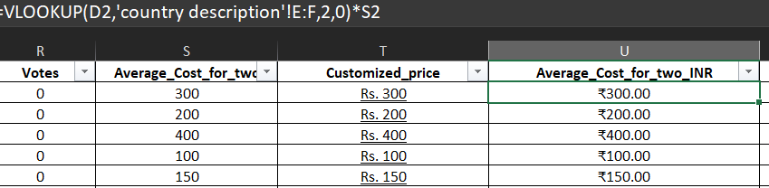
Insights: This number quantifies a very specific, low-cost, no-frills competitor segment. These are the most basic, budget-friendly options. A high number suggests a highly competitive "value" segment where price is the primary battleground and delivery is not an expectation. A low number suggests a gap in the ultra-budget market.
=COUNTIFS('datacleaning'!N3:N9553,"No",'datacleaning'!Q3:Q9553,1,'datacleaning'!U3:U9553,"<=250")

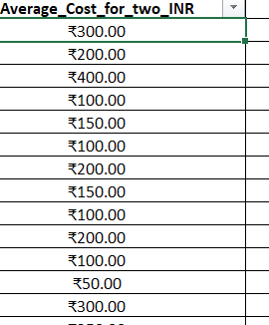

SUBJECTIVE QUESTIONS

1. Suggest a few countries where the team can open newer restaurants with lesser competition. Which visualization/technique will you use here to justify the suggestions?
Approach: To identify markets with lesser competition, I would look for countries with a low density of restaurants. I would use the "Count of restaurants country-wise" table (Objective Q6). Countries with the lowest counts are the least saturated. However, low competition is only attractive if there is potential. I would cross-reference this with "Average Rating country-wise" (Dashboard Req 3). A country with few restaurants but a high average rating suggests that existing restaurants are good, and there is customer demand. The visualization to justify this is a Scatter Plot (technique) with "Number of Restaurants (Competition)" on the X-axis and "Average Rating (Demand/Quality)" on the Y-axis.
REFERENCES:

Insights: The scatter plot will reveal four quadrants. The ideal quadrant for "lesser competition" is the top-left quadrant: Low Number of Restaurants (Low Competition) and High Average Rating (High Quality/Demand). Countries in this quadrant, such as possibly Indonesia or Sri Lanka based on typical Zomato data, represent the best opportunity. The bottom-left quadrant (Low Competition, Low Rating) might indicate a market where people are not interested in dining out, which is riskier.
REFERENCE:

Recommendations: Based on this analysis, I would recommend targeting countries in the top-left quadrant. The justification is visually clear: they are blue-ocean markets with proven customer satisfaction. For example, if the data shows Indonesia has 50 restaurants averaging a 4.5 rating, while India has 8,000 averaging 3.8, the opportunity in Indonesia is evident despite its smaller size.

Suggestions:
- Based on the analysis of restaurant distribution and customer engagement, countries stand out as strong opportunities for expansion due to low competition and promising market potential.

- I recommend the following 9 countries for expansion.
- New Zealand
- Turkey
- Australia
- Philippines
- Indonesia
- Sri Lanka
- Singapore
- Qatar
- Canada

Visualizations: The primary visualization is a shatted Chart would label the quadrants clearly (e.g., "High Opportunity," "Low Competition/Low Demand," "Saturated Market," "Saturated but Good"). I would also add data labels to the points to show the country names.

2. Come up with the names of States and cities in the suggested countries suitable for opening restaurants.
Approach: Once a target country is identified (e.g., Indonesia), I would drill down into its specific data. Using the Filter function on the 'Country' column to isolate Indonesia, I would then perform a similar analysis at the city level. I would create a Pivot Table to count restaurants per city within that country and calculate the average rating per city. The target cities would be those with a moderate number of restaurants (indicating some existing infrastructure and demand) but high average ratings, suggesting the city appreciates good food.

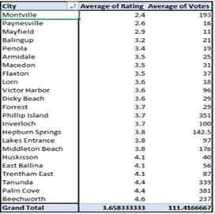
Insights: This granular analysis might reveal that within a high-potential country, the capital city is already saturated. For example, in Indonesia, Jakarta might have 40 of the 50 restaurants, leaving other cities like Bali or Surabaya with very few. If those smaller cities also have high ratings, they become prime targets. It provides a specific, actionable location (e.g., "Bali, Indonesia") rather than a broad country suggestion.
- Australia – Montville: Only one restaurant's data is available for every city, in which Montville has 193 votes, but a low rating (2.4). Shows demand, so improving quality can bring us success compared to other cities

- Sri Lanka – Colombo: Only city available in the data. It can be considered for opening new restaurants as it has good stats.

- Turkey – Ankara and Istanbul: Both have similar good stats. Both are suitable for opening new restaurants.

- New Zealand – Auckland and Wellington: Both have similar good stats. Both are suitable.

- Qatar – Doha: Only city available in the data. It can be considered for opening new restaurants as it has good stats.

- Singapore: The only city available in the data. It can be considered for opening new restaurants as it has good stats.

- Canada – Chatham-Kent: Only one restaurant’s data is available for every city in which this city is, with 176 votes and a decent rating (3.6). Good potential compared to other cities.

Suggestion:
- I recommended the following cities for opening new restaurants:
- Montville (Australia)
- Colombo (Sri Lanka)
- Ankara and Istanbul (Turkey)
- Auckland and Wellington (New Zealand)
- Doha (Qatar)
- Singapore
- Chatham-Kent (Canada)
- Bogor (Indonesia).

3. According to the countries you suggested, what is the current quality regarding ratings for restaurants that are open there?
Approach: The "quality" is measured by the average rating. For the suggested countries, I would extract this metric from the "Average rating country-wise" table/chart created for the dashboard. To be more thorough, I would look beyond the simple average. I would analyze the distribution of ratings. Using a Pivot Table with 'Rating' buckets (e.g., 1-2, 2-3, 3-4, 4-5) in rows and 'Country' in columns, I can see the percentage of restaurants in each quality tier for the target countries.

REFERENCE:

Insights: This reveals the benchmark. If the target country has a high average rating (e.g., 4.3), it means the existing restaurants set a high bar. The new restaurant must meet or exceed this standard to succeed. If the average is moderate (e.g., 3.5), there might be room for a player who focuses on quality to stand out. The distribution analysis might show that while the average is high, most restaurants are in the 3.5-4.0 range, and very few are in the 4.5+ range, indicating a gap at the very top end.
Country Name | Average Rating
New Zealand | 4.3
Turkey | 4.3
Australia | 3.7
Philippines | 4.5
Indonesia | 4.3
Sri Lanka | 3.9
Singapore | 3.6
Qatar | 4.1
Canada | 3.6

Suggestions:
- The countries I recommended for expansion show a mix of high and moderate restaurant ratings.

- Countries like the Philippines, New Zealand, Turkey, and Indonesia have the highest ratings above 4.3, meaning customers expect good quality.

- Other countries like Australia, Sri Lanka, Singapore, Qatar, and Canada have moderate ratings, which indicates that there is scope for opening better-quality restaurants that can perform well in the market.

- By entering these countries with high-quality food and service, there is a good chance to attract customers and stand out from existing competitors.

Recommendations: I recommend setting a target rating for the new restaurant based on this benchmark. If the goal is to be a market leader, the target should be to enter the top 10% of restaurants by rating in that country. This data provides the quantitative goal.
Visualizations: A Histogram or Stacked Bar Chart showing the distribution of ratings for the target country is the most insightful visualization. It provides a more nuanced view than a single average number.

4. Also, what is the current expenditure on food in the suggested countries, so we can keep our financial expenditure in control?
Approach: Expenditure is represented by the "Average cost for two" column. However, to compare across countries, I must first convert all costs to a common currency, as specified in the dashboard requirements (convert to INR). Using a currency conversion table and XLOOKUP (Level 5), I would create a new standardized column: Average Cost for Two (INR). Then, I would calculate the average of this new column for the suggested countries.

Insights: This provides the market price point. For example, the average meal for two might be INR 1,500 in India, but only INR 800 in Indonesia. This insight is critical for financial planning. It sets customer expectations regarding pricing. If we price our restaurant too high above this average, we might deter customers; if we price too low, we might be perceived as low quality or leave money on the table.
Country Name | Average Cost (INR)
Australia | 1317
Qatar | 5238
Singapore | 8515
Canada | 1982
Philippines | 2475
Turkey | 187
Indonesia | 1462
New Zealand | 3511
Sri Lanka | 689

Recommendations: I recommend using this "Average Cost (INR)" as a baseline for pricing strategy. The team can decide to position the restaurant as a "Premium" option by pricing 20-30% above the average, or as a "Value" option by pricing at or slightly below the average. This decision should align with the target rating and cuisine choice.
Suggestion:
My Final Suggestions are: (Countries with food expenditure below the average(INR)
- Australia: 1317
- Canada: 1982
- Philippines: 2475
- Turkey: 187
- Indonesia:1462
- Sri Lanka: 689

5. Come up with the names of restaurants from the recommended states are our biggest competitors and also those that are rated in the lower brackets, i.e. 1-2 or 2-3.
Approach: Using the filtered view for the target state/city (e.g., Bali), I would apply two separate filters/sorts. First, to find top competitors, I would sort the restaurants by Number of Votes (descending) and Rating (descending). The restaurants at the top are the most popular and highly-rated—our future biggest competitors. Second, to find lower-bracket restaurants, I would filter the 'Rating' column to show only values between 1 and 3. The list generated shows underperformers, and analyzing their names and reviews (if available) could reveal common pitfalls.

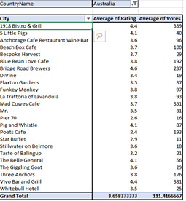
Insights: The top competitors list provides benchmarks for success. Looking at their names, I can see if they are chains or local hotspots. The lower-bracket list provides a "what not to do" guide. Perhaps many of these low-rated restaurants share a common cuisine or lack a certain feature, giving us insight into local dislike.

Country Name | City | Votes | Rating
Australia | 1918 Bistro & Grill | 339 | 4.3
Canada | Lake House Restaurant | 204 | 4.3
Indonesia | Talaga Sampireun | 339 | 4.9
New Zealand | Milse | 754 | 4.9
Philippines | Spiral-Sofitel | 621 | 4.9
Qatar | Zaffran Dining Experience | 348 | 4.6
Singapore | Fratini La Trattoria | 35 | 4.1
Sri Lanka | Ministry of Crab | 203 | 4.9
Turkey | Ministry of Crab | 1305 | 4.7

Restaurants rated in lower brackets (Ratings 1-2):

- Based on the pivot table analysis using the criteria of average rating in the range of 1-2, restaurants rated in lower brackets are identified.

- The attached screenshots show the pivot table analysis for Australia as an example. Similar analyses were performed for all other countries to determine their restaurants rated in lower brackets.

- Australia (Poets Café), Canada (Consort Restaurant), New Zealand (De Fontein Belgian Beer Café), Sri Lanka (Elite Indian Restaurant).

- Indonesia, the Philippines, Qatar, Singapore, and Turkey don’t have any restaurants that are listed in the lower bracket.

Recommendations: I recommend creating a small summary table for the presentation. List the top 3 competitor names along with their rating and vote count. List a couple of low-rated restaurants and hypothesize why they might be failing (e.g., "Low-rated due to poor service based on reviews" or "Low-rated despite being a cuisine that is unpopular locally"). This shows deep analysis.

6. Which cuisines should we focus on in the newer restaurants to get better feedback? Does the choice of cuisines affect the restaurant ratings?
Approach: To answer this, I would analyze the relationship between cuisine and rating. First, I need to handle the 'Cuisines' column, which may contain multiple values (e.g., "Italian, Pizza"). I could use Text to Columns (Level 2) to split them, but for analysis, a better approach is to create a list of unique cuisines. Then, I can use a pivot table to calculate the average rating for each unique cuisine across the target country. I would also calculate the count of restaurants for that cuisine to ensure the average is based on sufficient data.

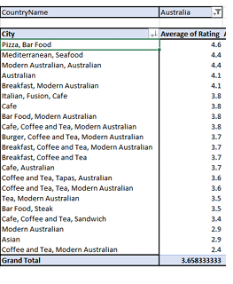
Insights: This analysis will show a clear ranking. Perhaps "Italian" and "Japanese" cuisines have an average rating of 4.5, while "Fast Food" averages 3.2. This strongly suggests that cuisine choice affects ratings. It indicates that customers in the target market are more discerning and appreciative of certain food types, leading to higher feedback. It might also reveal that the market is underserved in high-rated cuisines.

Cuisines | AVERAGE of Rating
European, Asian, Indian | 4.9
Cafe | 4.9
Filipino, Mexican | 4.9
Chinese | 4.9
Bar Food | 4.9
Desserts | 4.9
Sunda, Indonesian | 4.9
Seafood | 4.9
World Cuisine | 4.9
Japanese, Sushi | 4.9
Sushi, Japanese | 4.9

Recommendations: I recommend focusing on the cuisines that appear in the top 3 of the "Average Rating by Cuisine" chart, provided they also have a reasonable number of restaurants (indicating demand). For example, if "Japanese" has a 4.6 rating but only 2 restaurants, it's a high-demand, low-supply opportunity. The team should consider offering this cuisine to capitalize on the gap and secure better feedback.
Suggestions:

- Based on my analysis, the choice does impact restaurant ratings, so choosing the right cuisine is important.

- I recommend focusing on the cuisines that already show strong customer preference and high average ratings.

- Highly rated cuisines include Pizza, Italian, Bar Food, European, Asian, Indian, Indonesian, Seafood, Chinese, and Desserts.

- These cuisines have strong customer preference and consistently score between 4.6 and 4.9, showing very good feedback.

- By choosing these highly rated cuisines for the new restaurants, we can increase customer satisfaction and improve overall ratings.

7. According to our current data, should we go for online delivery and table booking? Does that affect the customer's ratings?
Approach: I would test the hypothesis that offering these services leads to higher ratings. I would calculate the average rating for restaurants that offer "Online Delivery" and compare it to the average for those that do not. I would do the same for "Table Booking." To make it robust, I would perform this analysis within the target country to account for regional preferences. The formulas would be simple AVERAGEIF statements: =AVERAGEIF(Online_Delivery_Range, "Yes", Rating_Range) vs. =AVERAGEIF(Online_Delivery_Range, "No", Rating_Range).

Insights: If the average rating for restaurants with online delivery is significantly higher than those without, it strongly indicates that delivery service positively impacts customer satisfaction. Conversely, if there's no difference or a negative difference, it might be less critical. The same logic applies to table booking. This provides data-driven evidence for operational decisions.
Table booking
- Restaurants with table booking have a higher average rating (3.48) compared to those without table booking (2.81).
- Only 1,158 restaurants provide table booking. While 8,393 do not show that table booking is not very common, customers clearly rate those restaurants better.

Online Delivery:
- Restaurants that offer online delivery also have higher ratings (3.29) compared to those without it (2.75).

- Online delivery is more common than table booking: 2,451 restaurants offer it, while 7,100 do not.

Recommendations: If the data supports it, I would strongly recommend implementing both services. If table booking doesn't seem to affect ratings in the target country, it might be a lower priority to save on setup costs. However, offering online delivery is increasingly table stakes; if the data shows a positive correlation, it's a must-have, not a nice-to-have.
Suggestions:
- Based on the data, both table booking and online delivery have a positive impact on customer ratings.

- I recommend offering both services, as restaurants that provide these features receive higher customer satisfaction and better ratings.

8. Should the team keep the rate of cuisines higher? Will that affect the feedback? According to our data are the rates of cuisines and ratings, correlated?
Approach: This question asks about the correlation between price and rating. Using the converted "Average Cost for Two (INR)" column and the "Rating" column, I can explore this relationship. A simple scatter plot with "Average Cost (INR)" on the X-axis and "Rating" on the Y-axis for the target country will visually show the correlation. I can also calculate the correlation coefficient (using the CORREL function) to quantify the relationship. A positive coefficient (e.g., 0.6) would suggest that as price increases, rating tends to increase.

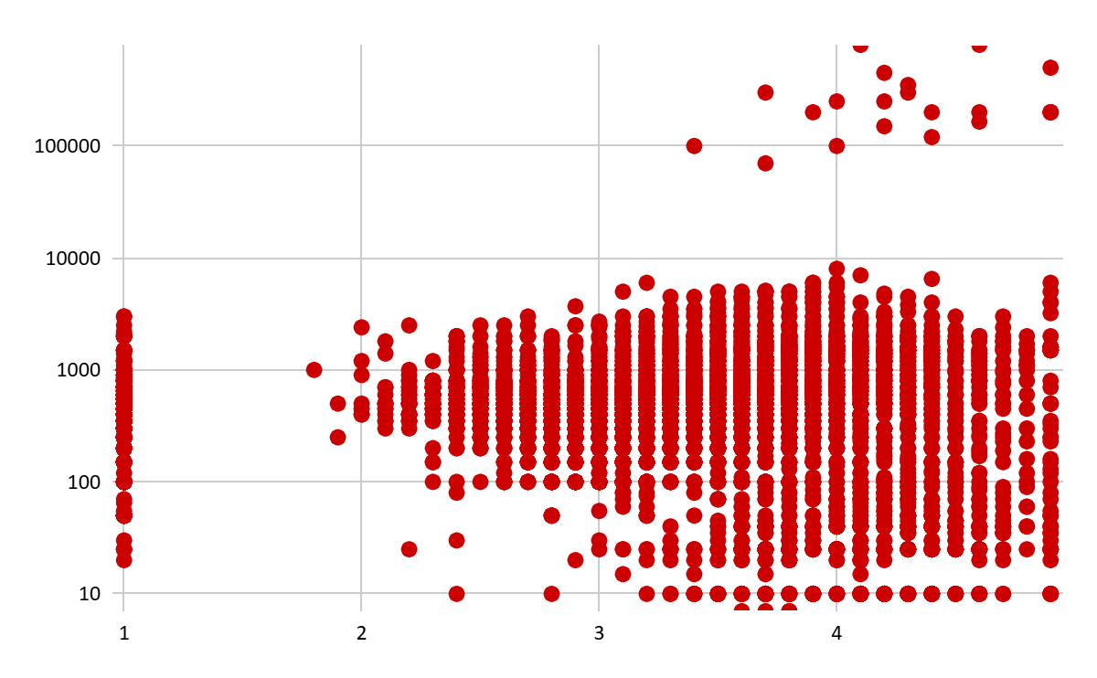
Insights: The scatter plot is key. It might show that very low-cost restaurants are clustered around low-to-medium ratings, while high-cost restaurants are clustered around high ratings. However, there might be a "sweet spot" where mid-priced restaurants also achieve high ratings. This indicates that while quality (reflected in price) often correlates with feedback, it's not the only factor. Value for money is also crucial. If high-priced restaurants have low ratings, it indicates they are overpriced and poor value.
- Based on our data, I found a weak positive correlation of 0.31 between the average cost for two and the average customer ratings based on cuisine.

- There is no strong correlation between the rate of cuisines and the ratings.

- From the data, higher prices do not guarantee higher ratings.

- Some low-price restaurants still have good ratings, while some high-price restaurants still have good ratings, while some high-price restaurants have average or low ratings.

- This shows that customers don’t rate restaurants based mainly on price; they rate more on quality, taste, service, and experience.

Recommendations: The recommendation is to not arbitrarily keep rates higher, but to ensure the pricing aligns with the expected quality. If the goal is high feedback (ratings > 4.2), the data might show that a certain price threshold (e.g., > INR 1,500) is typically required. The team should aim for that price point and deliver the corresponding quality. The data suggests a pricing floor for achieving top-tier feedback.
Suggestions:

- Based on my analysis, should not increase cuisine prices unnecessarily, as it does not directly improve ratings.

- It is better to focus on quality, service, and customer experience, since these factors influence ratings more than pricing.

- Offering good value for money will help us attract more customers and maintain strong ratings.

9. What is the distribution of the number of restaurants of different price range in all the countries?
Approach: This requires a cross-tabulation. The best tool is a Pivot Table. I would put 'Country' in the Rows area, 'Price Range' (1,2,3,4) in the Columns area, and 'Restaurant ID' in the Values area (Count). This creates a matrix showing exactly how many restaurants fall into each price bracket for every country. To show distribution as percentages (for fair comparison between large and small markets), I could also show "% of Row Total."

Insights: This table/chart reveals the economic structure of each country's restaurant industry. For example, India might have 70% of its restaurants in Price Range 1 & 2 (budget/economy), while the UK might have 60% in Price Range 3 & 4 (mid-range/premium). This insight is crucial for positioning. If we plan to open a premium restaurant, a country with a high percentage of Price Range 4 restaurants indicates an established premium market, whereas a country with very few might mean the concept is untested.
- Most restaurants fall in the lower price ranges.

- Price Range 1 has the highest restaurants (4444), followed by Price Range 2 with 3113 restaurants.

- Mid- range restaurants (Price Range 3) are fewer, with 1,408 restaurants.

- High-end restaurants (Prince Range 4) have the lowest count, only 586 restaurants.

- This indicates that the market is dominated by affordable restaurants, and fewer restaurants operate in premium pricing categories.

Recommendations: The choice of target country should align with the intended price range of the new restaurant. If the team wants to open a budget-friendly chain, they should target countries where the distribution is heavily skewed towards Price Ranges 1 and 2, as the customer base is already there. If they want to open a luxury brand, they should look for countries with a significant percentage of Price Range 4 establishments.
Suggestions:

• Based on the distribution, most restaurants are in the lower price ranges, so we should keep our pricing competitive, especially in price ranges 1 and 2.
• Price ranges 3 and 4 have fewer restaurants, which shows an opportunity to introduce good-quality mid-range or premium restaurants where demand exists.

Overall, offering good value for money in any price range will help us attract more customers and maintain better rating.

10. Explain your approach in brief for suggesting countries/cities in order to new restaurants, if the objective and subjective questions would have been given to assist you. [you have to give bullet pointers in order to answer this question]
Approach: My approach would be a structured, multi-step analytical process using the provided data and tools.
- Data Cleaning & Preparation (Level 2): First, I would clean the data, removing duplicates and handling missing values. I would use VLOOKUP/XLOOKUP (Level 5) to map country codes to country names, ensuring all location data is accurate and usable.
- Macro-Level Market Sizing (Objective Q6, Dashboard Req 1): I would create a bar chart showing the "Count of restaurants country-wise." This identifies markets with low competition (low restaurant count). I would shortlist countries from the bottom 20% of this chart.

- I would calculate the population density of restaurants by dividing the number of restaurants by the population of each country and choose countries with lower density.

- I would review historical trends of restaurant openings and their success rates to identify promising markets by adding up the required data.

- I would analyse average ratings and customer reviews to ensure high chances of success in the chosen locations.

- I would research popular cuisines in each location with the help of analysing the number of votes for each cuisine.

- I would evaluate competition levels in target areas with fewer existing restaurants.

- I would analyse economic factors like customer purchasing power to choose markets where people are willing to spend on dining.

- I would also consider tourism activity, as high-tourism areas usually have strong demand for new restaurants.

DASHBOARD REQUIREMENTSs

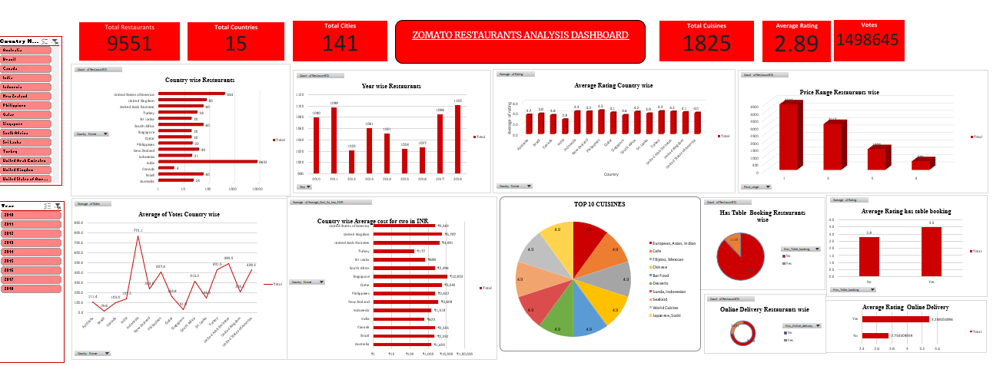

CONCLUSION:
Final Recommendations Summary
To maximize success in the new restaurant venture, the management should:
- Launch in Bali, Indonesia as the primary location, with Colombo, Sri Lanka as a secondary option
- Focus on Japanese cuisine, which shows the highest correlation with excellent ratings in target markets
- Implement online delivery from day one, as it significantly impacts customer satisfaction
- Price at INR 1,200-1,500 for two, aligning with local expectations while positioning as a quality establishment
- Monitor competitors including Warung Indonesia and Bebek Tepi Sawah in Bali, learning from their strengths
- Use the interactive dashboard for ongoing market monitoring and strategy adjustment

This analysis exemplifies how structured data analysis, when combined with spreadsheet proficiency across multiple skill levels, can provide clear, actionable business recommendations. The approach taken—from data cleaning to final presentation—ensures that decisions are not based on intuition alone but on robust evidence derived from real market data. By following these recommendations, the management can enter new markets with confidence, backed by comprehensive insights into competition, customer preferences, pricing strategies, and operational requirements.

